**LAB 2**

**EXERCISE**

In this exercise, you will create and manage the file structure for a fictional project.

1. Create the Project Directory

* In your home directory, create a new directory called my_project.

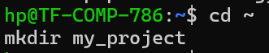

1. Build the Directory Structure

* Navigate into the my_project directory.
* Inside my_project, create three subdirectories: src (for source code), docs (for documentation), and data.



1. Create and Populate Files

* Create an empty file inside the src directory named main.c using the touch command.
* Using the cat command with redirection (>), create a file in the docs directory named readme.txt. Add the following lines of text to it:
* Project Alpha
* This is the main documentation file.

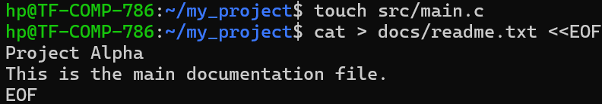

1. Copy and Move Files

* Create a backup of your readme file. Copy docs/readme.txt to docs/readme.bak.
* Create a new directory inside my_project called archive.
* Move the backup file (docs/readme.bak) into the archive directory.

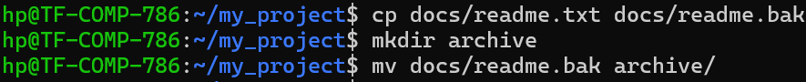

1. Manage Permissions

* Create a simple script: echo "echo Hello World" > src/run.sh
* Use ls -l src/run.sh to view its permissions. Notice it is not executable.
* Use the chmod command to make src/run.sh executable for everyone, but writable only by you (the owner). (Hint: 755).
* Make the readme.txt file read-only for everyone except yourself (the owner), who should have read and write permissions. (Hint: 644).
* Make the data directory completely private so that only you can access it. (Hint: 700).

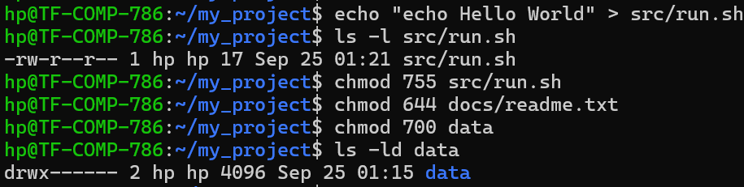

1. Cleanup

* Remove the entire archive directory and its contents with a single command.

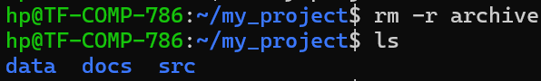

1. Conceptual Questions

* What is the practical difference between the permissions 777 and 775 on a directory?
* What command would you use to find out the file type of an unknown file (e.g., src/main.c)? (Hint: The command is file).
* What is the difference between the cp and mv commands?

**Difference between 777 and 775 on a directory:**

* 777: Everyone (owner, group, others) can **read, write, and execute** (full access).
* 775: Owner and group can **read, write, and execute**, but **others cannot write** (they only have read + execute).



**Difference between cp and mv:**

* cp **copies** a file/directory (original remains).
* mv **moves/renames** a file/directory (original is removed).